# Support Vector Machine in Sleep Stage Prediction Model

Support Vector Machine(SVM) is a supervised machine learning algorithm used for both classification and regression. The objective of SVM algorithm is to find a hyperplane in an N-dimensional space that distinctly classifies the data points. The dimension of the hyperplane depends upon the number of features. If the number of input features is two, then the hyperplane is just a line. If the number of input features is three, then the hyperplane becomes a 2-D plane.

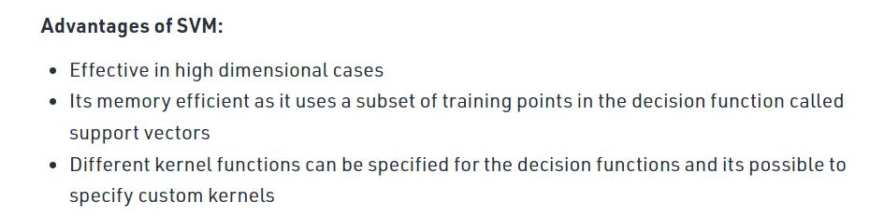

Support Vector Machines offer various kernel functions for the support vector classifiers. They are demonstrated in the example given below :-

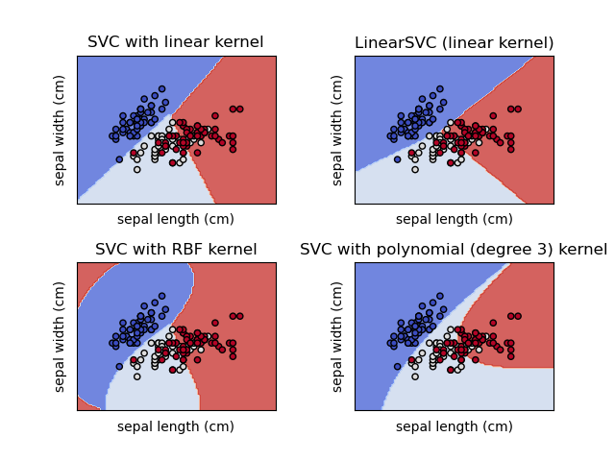

## Classification Report

### SVC(kernel = ‘linear’)

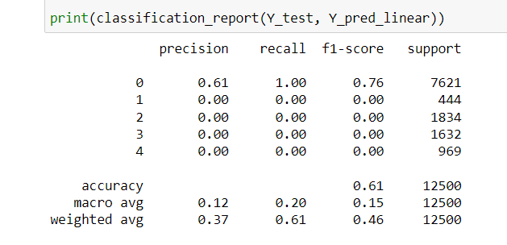

### LinearSVC

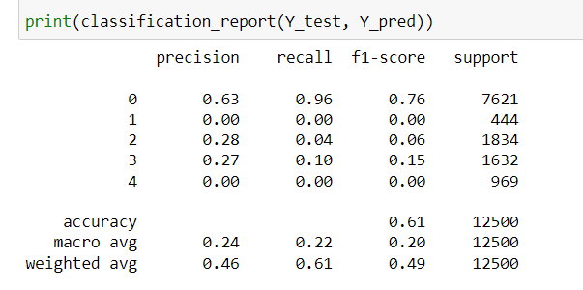

### SVC(kernel = ‘rbf’)

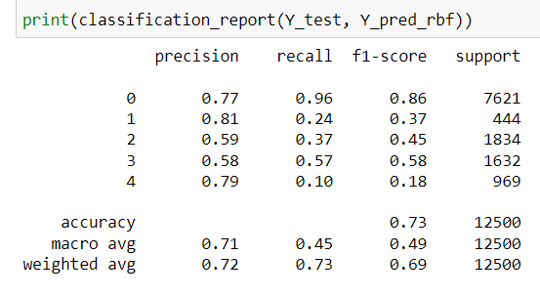

### SVC(kernel = ‘poly’)

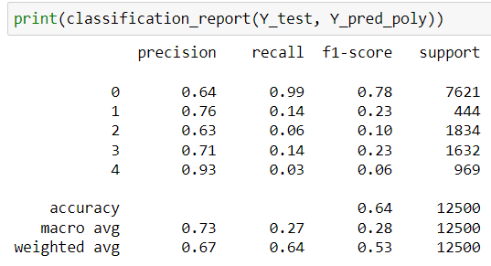

### SVC(kernel = ‘sigmoid’)

